July Holiday Programme 2025 – Mt Pleasant Oscar
Mon 30 June | Tues 1 July | Weds 2 July | Thurs 3 July | Fri 4 July
Edible Aquariums to make  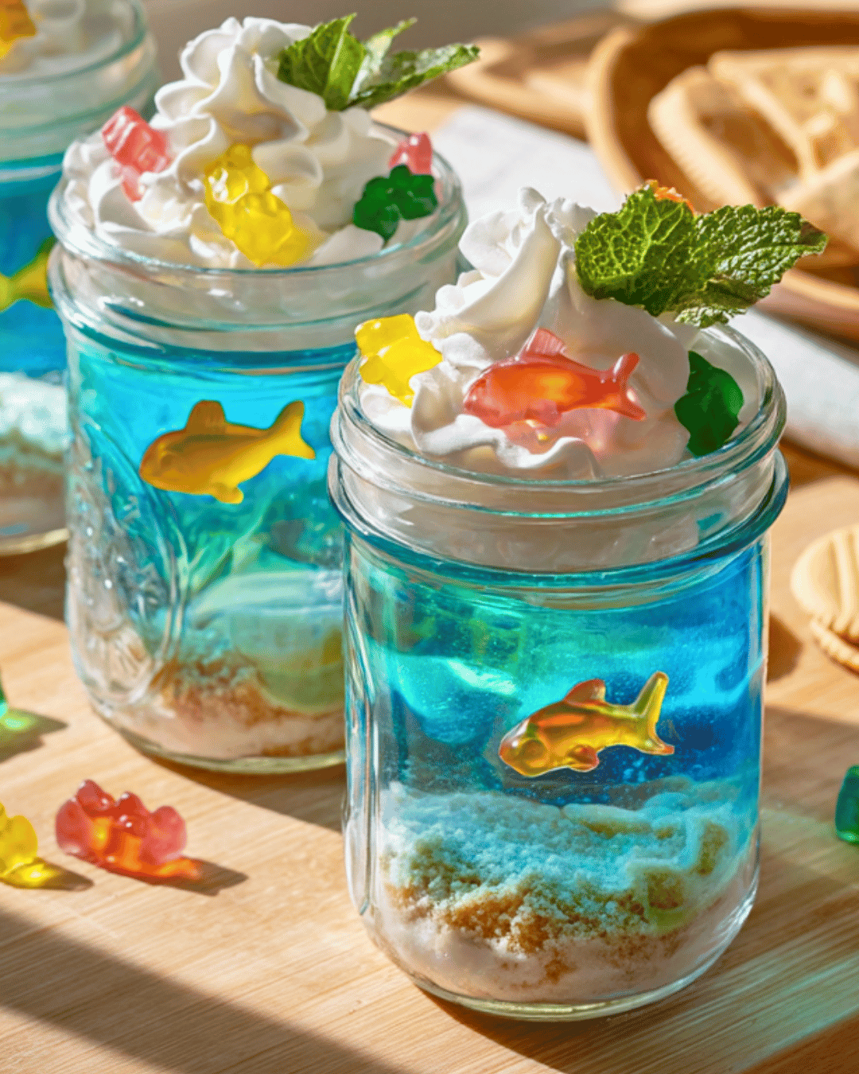  Dodge Ball  Pixel Art | Trip + $12  SpongeBob the Show at Court Theatre  (LIMITED SEATS)  Bus leaves 10.00am    Pompom critters to make  Learn card games – Trash and Solitaire | Fish and Chip lunch – optional  Soft toy to make  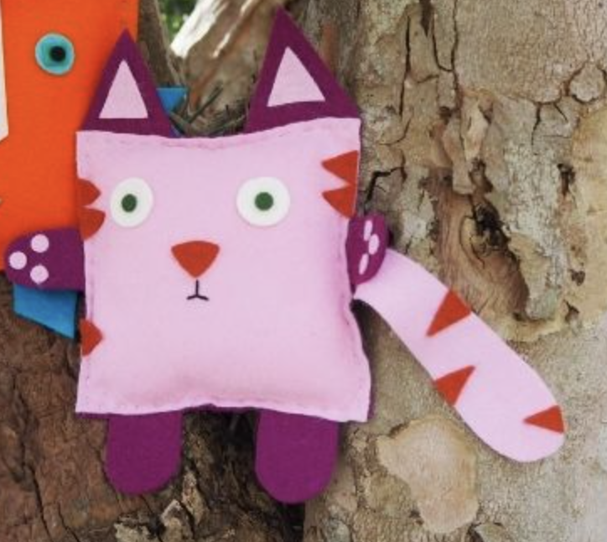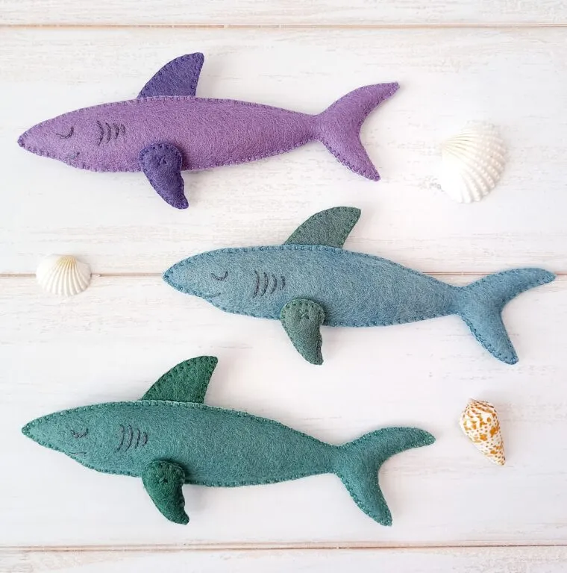  Tag Games  Make your own stickers | Make a ninja warrior and a ninja stress ball  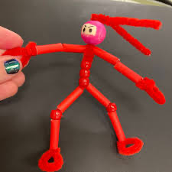    The Floor is Lava | Onsite visit +$12  Jax Critters  Jack is bringing his pet lizards in to meet you today!  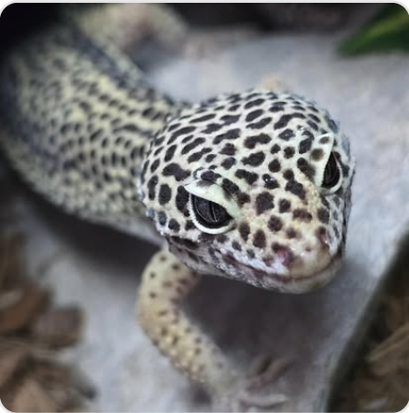  Make pipe cleaner lizards  Hide and Seek
Mon 7 July | Tues 8 July | Weds 9 July | Thurs 10 July | Fri 11 July
Plaster of Paris Moulds to paint  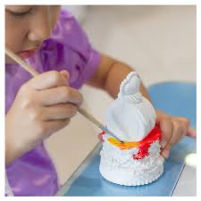  Manhunt | Pizza Lunch – optional  Wooden model kits to make up and paint  Around the World  Make your own stickers | Trip + $12  Mega Air Trampoline Park  Bus leaves 9.15am    Stained glass window art  Gaga Ball | Balloon Stomp  Bingo  Make your own egg timer  Egg timer challenges  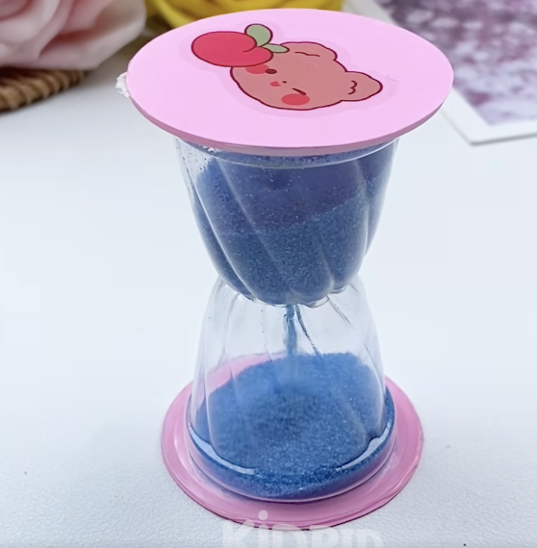 | Trip + $12  Come and watch ‘Night at the Museum’ at the New Brighton Museum! They are providing a drink and popcorn  Bus leaves 9.30am  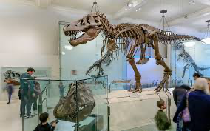  Wink Murder

The Details: (Note we finish at 5.30 in holidays)
- Please – once you have booked you need to make payment to: 38-9014-0645118-00 – please note we do charge for cancellations
- Cost per day for the July Holiday Programme is $51 per child until 3.00pm and $55 per child until 5.30pm plus an extra trip or activity fee ($12) on the following days: Week 1 Tues 1/7 Trip to see SpongeBob show, Fri 4/7 Jax Critters, Week 2 Weds 9/7 Trip to Mega Air, Fri 11/7 Trip to Movie and New Brighton Museum
- Programme hours are 8.30-3.00pm ($51) or 8.30-5.30 ($55)
- Pizza and fish and chip days are optional – pizzas are currently $7 each from Dominoes and I will send the fish and chip options out the night before fish and chip lunch day. Pizza Day – Tues 8/7, F+C day is Weds 2/7. Please bring cash on these days – we will have change
- If your child is unwell – please don’t bring them to the programme
- If your child behaves in a way that puts themselves or others in danger or is behaving in a way that another person’s enjoyment is being affected, we will warn them but after this we will phone you to collect your child. A refund will not apply – please talk to your child about following the instructions of our staff
- For the $51.00 rate to apply please collect your child by 3.00 pm
- Our earliest bus leaves at 9.15 am and this is Wednesday 9/7 . Please be here in time for this as we cannot hold up the bus. The other buses leaves– 10.00 am Tues 1/7 and 9.30am Friday 11/7
- Please bring water bottles – especially on trip days as we can’t guarantee we can get to a water fountain
- For the movie trip day – the museum are giving us a small bag of popcorn and a drink. The kids are welcome to bring any of their own snacks as well
- Please make sure your child has warm layers and a jacket – ideally named please
- The kids get a bit hungrier than usual in the holidays so please pack an afternoon tea for them – they are usually pretty active throughout the day
- You can book by emailing Kath at markath@xtra.co.nz

